

JUNE 2022

162

Discerning the Salesian Missionary Vocation

Missionary spirit is the heart of pastoral charity summed up in Da mihi animas, Caetera Tolle. All Salesians are called to live this as an ‘essential feature of Don Bosco’s charism’ (Fr. Viganò).

The Salesian missionary vocation instead, is a gift of the Lord, a call reserved to some. The Salesian missionary does not mean belonging to an élite group of privileged confreres. He is someone who lives in a more generous and radical way the common Salesian vocation of all the confreres. The missionary vocation is invoked in prayer, awakened in living among the confreres, verified in their discernment, and **accompanied** in their growth.

It is through prayer that those who are attracted to the missionary life discover, sustain, and nurture their call. Daily prayer helps one to be attuned to God’s call. In prayer, one encounters God by bringing before Him questions which the Holy Spirit has stirred in one’s heart, one’s dreams, struggles, and worries.

The following **Initiatives** to foster missionary animation are important means to keep alive the missionary spirit of all Salesians and the whole of the Educational Pastoral Community: prayer for missionaries every 11th of the month; use of *Cagliero11* and *CaglieroLIFE* videos; celebration of the annual *Salesian Mission Day*; summer missionary experience abroad (for Salesians in initial formation); missionary youth groups; and the Salesian Missionary Volunteer Movement. Thus, an effective missionary animation gives birth to Salesian missionary vocations.

St. John Paul II wrote that “love is the fundamental and innate vocation of every human being” (*Familiaris Consortio*, no.11). Every person has a unique, unrepeatable vocation to love. Discerning one’s missionary vocation means discerning how God is calling one to love and live in a more generous and radical way one’s Salesian vocation.

Accompaniment is an important way to help clarify the deep desires of one’s heart. Discernment requires openness to the spiritual guide, time, patience, and perseverance. The spiritual guide is a ‘friend of the soul’ who helps one through confusion and sometimes frustration which can be part of the discernment process.

If you think God is calling you to be a Salesian Missionary: *pray, have a spiritual guide, and discern*!

▀**Fr. Alfred Maravilla, SDB**

Councillor General for the Missions

Dearest friends*,*

Cordial greetings to you with great hopes in this difficult time of war which overwhelms, worries and commits us to be present in the most crucial places, with the people and for the people who are suffering.

We, as Daughters of Mary Help of Christians, during the last General Chapter we committed ourselves to *take up missionary synodality as a way of life*. We would like to tread the alternative path, by synergizing the diversity of vocations and charisms, in order to live in the contemporary world of today. We believe that the Salesian spirituality is the bearer of spiritual and human values which can transform the reality that affront us.

Living the Salesian Spirituality means, embodying the Preventive System, educating the new generations "together" in dialogue, with faith in the strength of gentle, non-violent solutions.

In communion with many families, we live the commitment to nourish the "Family Spirit" every day and we continue to work for peace.

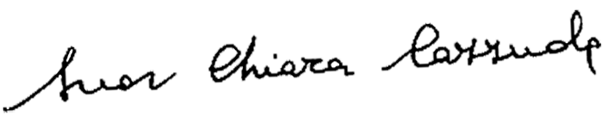

▀ **Sr. Chiara Cazzuola, FMA**

Superior General of the Daughters of Mary Help of Christians

FOR REFLECTION AND SHARING

▀ What is needed to discern the missionary vocation?

▀ In my opinion, what difficulties are there in order to respond to the missionary vocation?

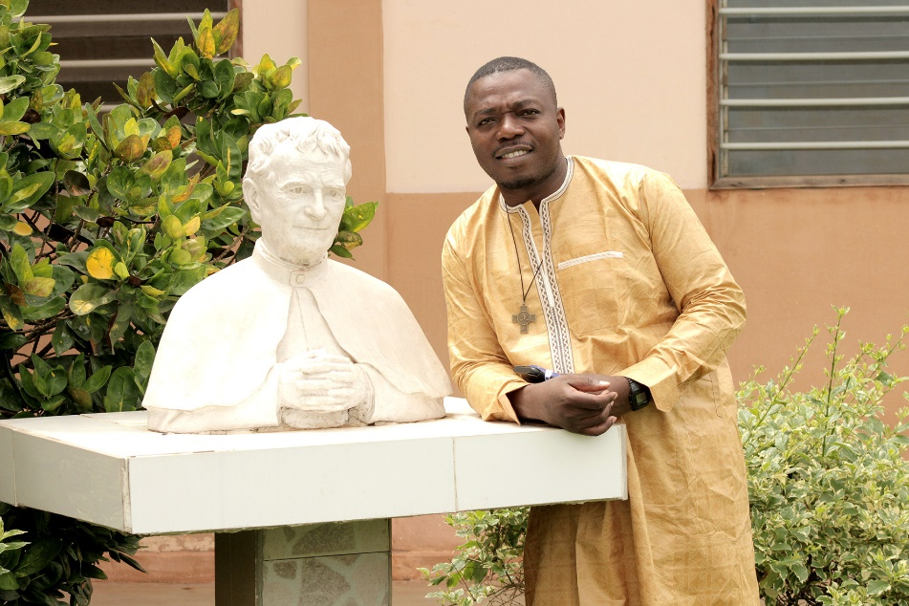MISSIONARY   
PRESENCE AMONG   
THE FAMILIES IN CIAD

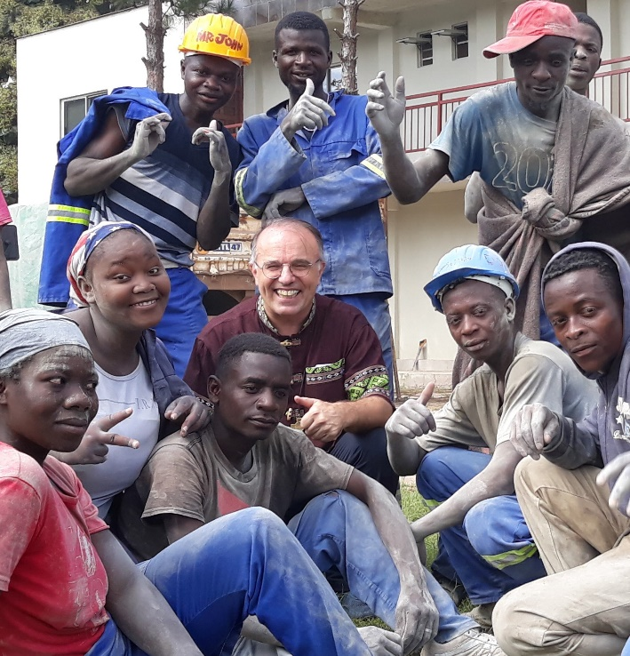

*Fr. Mathieu, does the Salesian presence in Chad have missionary characteristics or elements?*

The Catholic Church in Chad is one of the youngest churches in Africa. It is less than a hundred years old and the Salesians have been here for about 26 years. They began first in the south in Sarh before spreading to N'Djamena and Doba. The Salesian presence in Chad has missionary characteristics. It is a place that emanates joy. The joy of Christ which we share with the population in the simplicity and gratuitousness of the gift of self. It is a presence which adapts to the conditions of life and faith of its people. It transmits faith to everyone here. In our missionary work, we try to be close to the people through our lifestyle, listening and accompaniment.

*How is the Salesian pastoral care of families in Chad?*

The Salesian pastoral care of families in Chad and precisely at Sarh consists in the accompaniment of families -especially of young couples in the first years of their marriage. In another level it is the formation accorded through the parochial commission of the family, especially through the preparation for marriage and the follow up of the couples in the first five years of marriage. We visit families to come to terms with their realities. We also work for the education of children from disadvantaged families, and we support them. We also train young people in obtaining life-coping skills, educate them on the harmful effects of alcohol on a person and its impact on families.

*How do you support broken families or those with difficulties in family life?*

For the moment, the first thing is accompaniment. For marriages that don't work, we mediate with parents and the extended family. Sometimes we propose a temporary separation of partners as a buffer time to reflect better and calm down before getting back together. For broken marriages, we accompany them, especially the women, who generally struggle to take care of their children.

**Fr. Jean Mathieu Pola Tafopa**

Salesian of Don Bosco, Cameroonian and on mission in Sarh in southern Chad. He was born on July 15, 1980. First profession in 2007, ordained a priest in 2016.   
His first mission was in Gabon.

In his community he is the Rector and Parish Priest   
of the parish of St. Joseph. He also teaches at the parochial school.

He is proud to work with young people in Don  
 Bosco’s style.

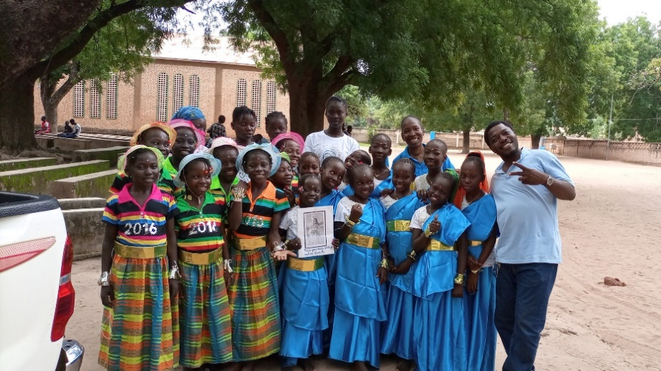



Waste of Food

• In the world 17% of the food available for consumption is wasted.

• This figure corresponds to 23 million fully loaded 40-ton trucks (930 million tons).

•  2.37 billionpeople did not have the opportunity to eat properly.

• Wasted food comes for the most part from families, who discard 11% of food, while supermarkets, restauration and outlets waste 7%.

The countries with the highest annual per capita waste: 1. Saudi Arabia 105 kg; 2. Australia 102 kg; 3. Mexico 94 kg; 4. Turkey 93 kg; 5. France 85 kg; 6. Canada 79 kg; 7. Indonesia 77 kg; 8. Great Britain 77 kg; 9. Germany 75 kg; 10. Argentina 72 kg; 11. Korea 71 kg; 12. Italy 67 kg; 13. China 64 kg; 14. Japan 64 kg; 15. Brazil 60 kg; 16. USA 59 kg; 17. India 50 kg.

***Source: “Food Waste Index Report 2021” of the United Nations Program***

FORUM

**Families**

For mutual respect and Christian love   
within families in the Salesian presences **in Chad**.

We pray for Christian families around the world; may they embody and experience unconditional love and advance in holiness in their daily lives. [Pope Francis’ prayer intention]

JUNE

SALESIAN

MISSIONARY

INTENTION

AFRICA

